Table of Content
Introduction………………………………………………………………………………………….... 3
Discussion of Data Generation……………………………………………………………………….. 4
Action and Outcome………………………………………………………………………………….. 5
Hierarchy Chart………………………………………………………………………………………. 6
Discussion…………………………………………………………………………………………. 6
Cross Reference Chart……………………………………………………………………………….. 8
Connection to Systems…………………………………………………………………………….. 8
Smart Integration…………………………………………………………………………………....... 9

Introduction
The functional decomposition breaks down the complete problem into systems designed to perform fundamental actions that come together to resolve the problem at hand. The problem is NASA does not have a way to independently control the temperature of the incoming hydrogen when it reaches the test articles. The resolution was to design a device that will allow NASA to set the inlet hydrogen temperature to a desired value. With the use of gathered customer needs and considering the key goals of the project, the functional decomposition of a hydrogen pre-heater was created. With the aid of a Hierarchy Chart and cross-reference chart, the functional decomposition was diagnosed. Using the cross-reference chart, connections between the systems and their functions could be found and further investigated to see which are most important. This helps to narrow down the design process and obtain a clearer scope of how the problem will be solved.

Discussion of Data Generation
Data for the functional decomposition was generated based on the responses from the customer needs and the project scope. These requirements were then split into their most basic subsystems needed for the system to operate. According to the customer needs, the hydrogen needs to be independently heated upon entering the test chamber. Furthermore, the customer also states that the parameters to be controlled are the power delivered and the geometry of the coils. From this, the functions of the device were specified, and the hierarchy chart and cross-reference table were constructed.

Action and Outcome
The goal of the project is to pre-heat the inlet hydrogen in the test chamber. The device will allow for different inlet temperatures to be set based on customer needs. The device will have an interface that allows the user to input a desired temperature and the control device will modulate the heating device to achieve the required hydrogen temperature.

Hierarchy Chart
Using all the data and information listed above, the team was to create a hierarchy chart based on the needed systems and functions. The hierarchy chart is a flow chart starting with our problem and breaking down into systems and fundamental functions that need to be achieved to solve the problem at hand. Below is our hierarchy chart for our problem: creating a hydrogen pre-heater for NASA’s test chamber.

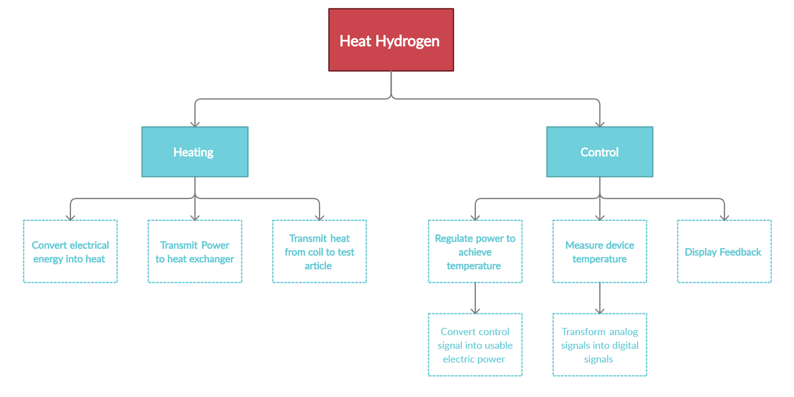

Discussion
The following hierarchy charts shows the system and its related subsystems, in descending order of specific functions. The subsystems were split into their constituent parts by reviewing the customer statements to get an idea of all the relevant functions. The main function is to independently control the temperature of the hydrogen at the inlet, so the first system is termed “heat hydrogen”. The two primary subsystems branch off into controlling the temperature and the physical means of heating. The first step in heating the hydrogen is to provide power from an external source and transmit it to the induction coils that surround the test article. Then, the heat must also be transmitted from the induction coil to the test article, so this is a function. The controller subsystem works with the heating device subsystem in that it is the decision-making part of the design. A controller is essential in determining the power output of the heating device. This is the reasoning for the modulation of power subsystem. Measurement devices are also required in any traditional controller because it provides the user or computer program information about the environment to be able to make decisions. This is also the reasoning behind the controller displaying feedback, because it is important for diagnosis. It should be noted that the induction coil is repeatedly specified as the heat transfer device because the scope of the project does not include design freedom of the type of heat transfer device.

Cross Reference Chart
The cross-reference chart indicates which systems fulfil which of the fundamental functions needed to resolve the problem of the project. For our cross-reference chart, we chose “Heating” and “Control” as our systems since these systems are the fundamental ones needed for the device.
Functions | Systems
 | Heating | Control
Power transmission from source to induction coil | X
Heat transmission from induction coil to test article | X
Regulate power | X | X
Measure temperature |  | X
Display feedback |  | X
Convert electrical energy to induction heating | X | X
Convert control signal to power | X | X
Convert analog to digital signals |  | X

Connection to Systems
From the cross-reference table, it can be concluded that the “control” system is the most important to the project, as it fulfils 6 functions. Therefore, it is the highest ranked system. This makes sense because the control system is the priority for decision making in the entire project. Although the heat system is important, most of its subsystems are constrained by simpler concepts like material properties and physics. The control system requires more attention because of its complex subsystems like data processing and conversion of electrical signals. The subsystems of control largely influence the goal of providing feedback through measurement and display of electrical signals. Measurement of the environment and providing feedback was a top priority. The heating system is the backbone of providing an actual temperature difference in the system. Therefore, it is a priority as well. Its relation to the resulting subsystems involves the delivery of electrical power to usable heat. The heating system is also governed by simple equations like the equations of heat transfer and power from current through a wire. Therefore, heating is the second highest ranked system.

Smart Integration
The cross-reference table also provides a display of the relationships between subsystems and allows the investigation for any possible integration of subsystems. Since heating and control require that both systems work in unison, overlap of functions is expected. For example, the regulation of power is a function that is directly related to heat output, but regulation implies change, which requires some sort of control. Since there are nonlinear energy losses present in the physics of the problem, the functions might be integrated by forming linear relationships to proportionally link change in power to heat output. Converting electrical energy to inductive heating also experiences overlap, mostly because electrical energy normally produces standard resistive heating. The project uses eddy current heating, or induction heating where the properties of the current delivered are related to the performance of the heating in the induction coil. For example, direct current, or poorly inverted alternating current will not result in good induction heating. Another function that is shared by both the control and heating system is the conversion of controls signals to power. This is an extremely crucial overlap, because the control system is what outputs the correct signals, the gateway to releasing large amounts of energy. These functions are inherently integrated. The reason for this is that no conversion takes place. From a physics standpoint, the integration is that the control signal is the same as the power signal, with a larger amplitude.

